Nomination Papers

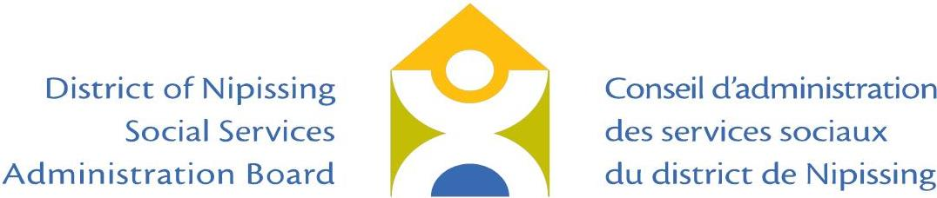

District of Nipissing Social Services Administration Board

I, _________________________, of _____________________,
(Name of Candidate/Nominee) (Qualifying Address)

and ______________________ , ___________ hereby put forward
(Mailing Address) (Postal Code)

- my name as a candidate for the office of DSSAB member representing Territory Without Municipal Organization (TWOMO) and I further declare that I am legally qualified to hold office for which I have been nominated.

_______________________________ ___________________
Signature of Candidate/Nominee Date

Business Phone: _______________

Home Phone: _______________

Cell Phone: _______________

Fax #: _______________

E-Mail: _______________

Note: A person who has been nominated may withdraw his/her nomination by filing a written withdrawal with the Returning Officer by 2:00 p.m. on August 19, 2022.

A candidate who is running for municipal office may run as a member to represent DSSAB but, if elected to both positions, is permitted to hold only one office.

