|  |
| --- |
| The District of Nipissing Social Services Administration Board |
| CORP-2024-001 2024 DNSSAB Budget |
| January 31st, 2024 Board Meeting |

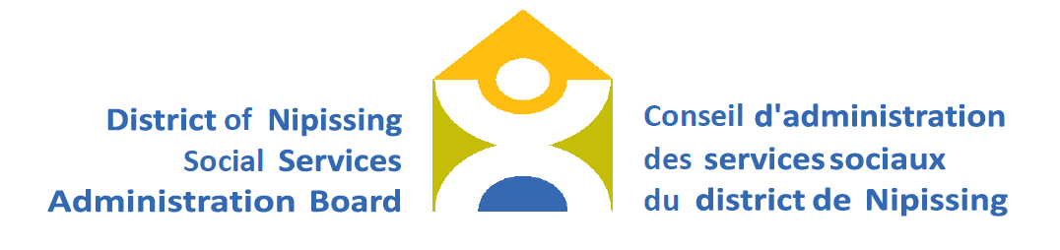

|  |
| --- |
|  |

Table of Contents

1. Purpose 2

2. Background 2

2.1 Cost Pressures 3

3. Report 4

3.1 Budget Overview 4

3.2 Ontario Works 5

3.3 Children’s Services 8

3.4 Housing Services 11

3.5 Paramedic Services 15

3.6 Community Paramedicine 19

3.7 Healthy Communities Fund 20

3.8 Corporate Services 21

3.9 Board 23

3.10 Summary 24

4. 2025 Outlook 25

4.1 Ontario Works Program Delivery and Employment Assistance Funding 25

4.2 Children’s Services 25

4.3 Housing Services 25

4.4 Paramedic Services 25

# Purpose

The District of Nipissing Social Services Administration Board (DNSSAB) 2024 budget has been developed with an emphasis on stable financial planning and maximizing service delivery. This is a prudent financial plan, which promotes continued excellence in client service with a continued desire to find efficiencies in service delivery and program planning.

# Background

The DNSSAB administers and delivers provincially mandated services on behalf of the citizens of the District of Nipissing in an equitable and cost-effective manner. These services include delivery of Ontario Works (OW) programs, Paramedic Services, and the administration and service system management for Childcare and EarlyON programs and Social Housing and Homelessness programs.

The DNSSAB’s service area includes:

* The City of North Bay
* Municipality of West Nipissing
* Municipality of East Ferris
* Municipality of Temagami
* Township of South Algonquin
* Township of Bonfield
* Municipality of Calvin
* Township of Papineau-Cameron
* Town of Mattawa
* Township of Chisholm
* Township of Mattawan
* Territories without municipal organization (TWOMO)
* Nipissing and Temagami First Nations

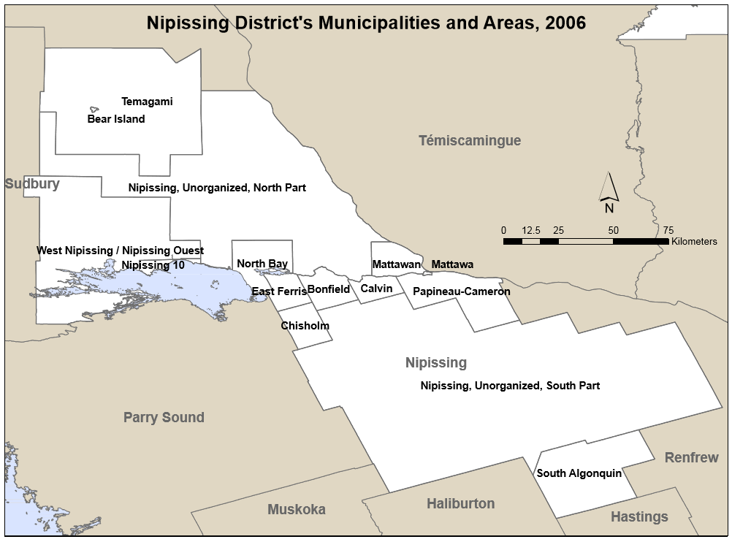

## 2.1 Cost Pressures

In September 2023, the 2024 Budget Issues Report, #CORP-2023-034, was presented to the Board, which detailed the expected budget pressures for 2024. Within the Budget Issues Report, it was noted that the Paramedic Services budget was expected to see significant pressures due to inflation, collective bargaining, and current costs being higher than expected. Per page 16, there is an 11.9% year-over-year increase to the Paramedic Services budget.

Here are the highlights of the other budget pressures for 2024:

* Inflationary increase to most goods and services as inflation continues to be very high. Canada’s inflation rate is expected to be approximately 3.5% until the middle of 2024.[1] The high levels of inflation will continue to have a direct impact on the DNSSAB budget.
* Collective bargaining increases. The Canadian Union of Public Employees (CUPE) Local 4720-02 (NDHC staff) collective agreement expires December 31, 2023, and Local 4720-01 (non-paramedic DNSSAB staff) collective agreement also expires January 31, 2024. Therefore, with new collective agreements needed, annual payroll increases are estimated for the 2024 budget.
* Increased ambulance call volumes which has led to increased paramedic deployment.
* Continued significant demand for homelessness services and supports.

The 2024 budget does not anticipate any significant provincial or federal funding changes. However, it should be noted that some funding allocations, such as the land ambulance service grant, are not confirmed until well after the budget is prepared and approved. For these programs, provincial/federal funding included in the 2024 budget is estimated based on previous year funding allocations and trends.

Specific departmental cost pressures and provincial funding changes will be examined further in each respective department section.

# Report

## 3.1 Budget Overview

The 2024 budget presents a municipal levy increase of $674,772 (2.99%) with an overall increase in the budget of $4,542,700 from $90,232,483 in 2023 to $94,775,183 in 2024.



The budget maintains services at the 2023 level while including any service changes that the Board approved in 2023. Here are some highlights of the significant changes from the 2023 budget:

* The Homelessness Prevention Program funding increased from $2,339,100 to $5,303,700 has eased pressure on the levy in the Housing Services budget.
* As noted previously, there are significant increases to the Paramedic Services budget due to inflation, collective bargaining, and increased call volumes which has led to increased paramedic deployment.
* The budget includes the use of $934,000 in reserves to offset the impact on the municipal levy from the Paramedic Services deployment changes.

Additional details will be reviewed in further detail throughout the report.

## 3.2 Ontario Works

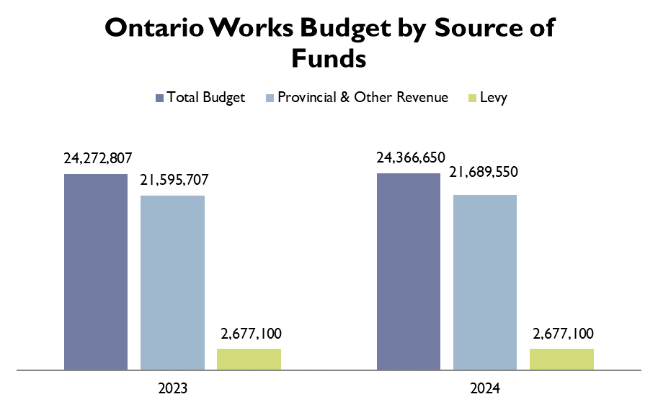



* In 2024, the Ontario Works budget has increased year over year by $93,843 or 0.04% with no change in the municipal share.

#### 3.2.1 OW Provincial Funding Impact

* On August 24, 2023, the Ministry of Children, Community and Social Services (MCCSS) confirmed that the 2024 Ontario Works program delivery and employment funding allocations would be maintained at the 2023 levels and that financial recoveries for underachievement of outcomes will be waived for 2023 and 2024 while MCCSS continues to work towards the employment service transformation.
* Ontario works program delivery and employment provincial funding has now been frozen for six years (2019 through 2024) at 2018’s actual expenditures.
* The freezing of provincial funding shifts the inflationary budget pressure solely on to the municipalities. Costs of inflation were previously cost shared 50/50 with MCCSS before funding was frozen in 2019. Savings have been identified in recent years to reduce any impact on the levy; however, continuous savings to limit increases to the municipal levy will not be possible if MCCSS does not provide inflationary increases to funding.

#### 3.2.2 OW Programs

* OW financial assistance and mandatory benefits have been 100% funded by the Province since 2018. Discretionary benefits are also provincially funded but are capped at $10 per average caseload with any costs exceeding the cap being municipally funded.
* Type B municipal funerals/burials for non-social assistance recipients are 100% municipally funded. This service is not mandated by the DSSAB Act and the DNSSAB provides this service on behalf of its member municipalities.
* In 2024, the only costs that remain cost shared are program delivery and employment services. Below is a summary of how the various OW programs are funded:

|  |  |
| --- | --- |
| Program | Funding Source |
| Financial Assistance | 100% funded by the MCCSS |
| Mandatory Benefits | 100% funded by the MCCSS |
| Discretionary Benefits | Funded by MCCSS up to a cap of $10 per average caseload |
| Funerals – Type B | Funerals for non-social assistance recipients are funded by the municipal levy. These funerals are a municipal responsibility that DNSSAB oversees for its member municipalities. |
| Employment Assistance and Program Delivery | Employment assistance and program delivery is combined into one pocket of funding from MCCSS. MCCSS currently provides $2,074,900 in 100% provincial funding and an additional $2,627,100 in 50/50 funding for total provincial funding of $4,702,000. The matching levy contribution is $2,627,100. |

* OW financial benefits costs are expected to increase slightly in 2024 from budgeted expenditures for 2023 by $129,843 or 0.84%. It was expected that financial assistance costs would rebound to the pre-pandemic levels after the expiration of Federal benefits such as the Canada Recovery Benefit (CRB) in 2021, however, the caseload has been increasing much slower than originally anticipated. As mentioned previously, these costs are fully uploaded to the Province and therefore have no impact on the municipal levy.
* The average monthly caseload in 2024 is expected to be 1,888, which represents a 3.68% increase from the budgeted average monthly caseload of 1,821 for 2023.[2] The 2023 year-to-date (YTD) actual average monthly caseload was 1,806 as of October 31, 2023.
* The annual average cost per case in 2024 is budgeted to be $685.89 compared to $705.27, the annual average budgeted in 2023. This change is based on current trends.
* Mandatory and discretionary benefits budgets have been adjusted based on recent trends and expected caseload changes.
* Employment assistance expenditures are decreasing $12,000 (2.80%) due to the ending of an outsourced employment program which is partially offset by increases to direct client benefits.

#### 3.2.3 OW Program Delivery

* The $12,000 increase in program delivery costs is due to inflation. The increase in the budget has been limited to the cost sharing threshold with MCCSS to not result in any increases to the municipal levy, given the high budget pressures in other departments in 2024. As mentioned previously, without inflationary increases to provincial funding allocations, inflation will eventually result in increases to this budget as cost saving opportunities are exhausted.

## 3.3 Children’s Services

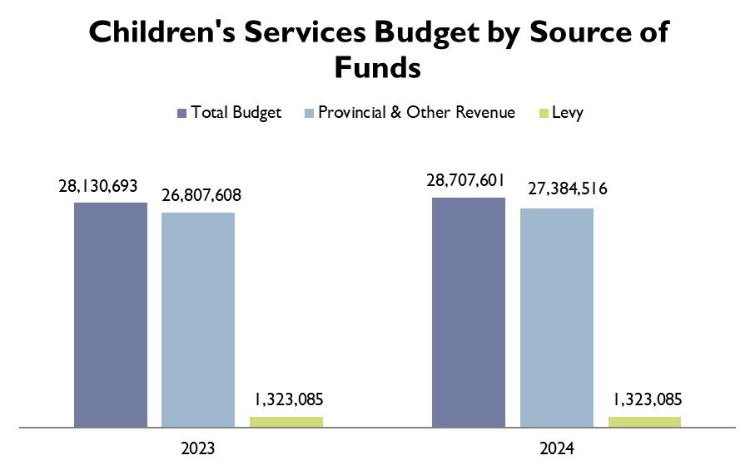



* In 2024, the Children’s Services budget has increased year over year by $576,908 or 2.05%. This is due to an increase in the Canada-Wide Early Learning & Childcare (CWELCC) funding which is partially offset by a decrease in provincial administrative funding (further details below) and the ending of the Skills Development Fund, which was a one-time project.

#### 3.3.1 Children’s Services Provincial Funding Impact

In 2019, The Ministry of Education (EDU) announced the following funding changes that were originally planned to be implemented over the three-year period of 2020 to 2022:

* On January 1, 2020, Consolidated Municipal Service Managers (CMSMs) and District Social Services Administration Boards (DSSABs) were asked to cost-share Expansion Plan operating funding at a rate of 80/20 provincial/municipal.
* On January 1, 2021, CMSMs/DSSABs were asked to continue cost-sharing Expansion Plan operating funding at a rate of 80/20 and were required to cost share most administrative funding at a rate of 50/50; and
* On January 1, 2022, the threshold for allowable administrative funding that CMSMs/DSSABs can spend on childcare was reduced from 10% to 5% in addition to the ongoing cost sharing requirements previously introduced.

For the last two years (2022 and 2023), the EDU has provided one-time funding of $605,748 each year to offset the impact of the administrative funding changes noted above. The one-time funding will not be provided in 2024 and future years. This change results in a decrease of approximately 33% in administrative funding for Children’s Services and does not align with the reporting requirements that the EDU has been requesting. With the implementation of the CWELCC system, there is intensive reporting and childcare provider oversight required. Such a significant reduction in administrative funding will limit DNSSAB’s ability to meet these requirements. Advocacy efforts will be made to communicate this issue to the Province.

This change is not expected to impact the 2024 budget as Children’s Services is able to use the unspent portion of the previous years’ one-time funding until March 31, 2024. This will help offset the funding reduction in 2024.

#### 3.3.2 Children’s Services Programs

* The total 2024 Children’s Services budget is the amount set out in the transfer payment agreement (TPA) with EDU. The municipal levy allocation is the minimum cost share requirement based on the TPA.
* Since the EDU changed the cost sharing formula for Expansion funding in 2020 from 100% provincial to an 80/20 split, they made the 20% municipal portion optional in response to feedback from municipalities, CMSMs and DSSABs. The previous Board decided to continue funding the 20% municipal portion of the Expansion funding so there would be no negative impacts on the availability of high-quality licensed childcare spaces in the district. The 2023 budget removed this optional municipal contribution of $423,431, given the estimated increase to the municipal levy to fund Northern Pines, the Low Barrier Shelter, and emergency overflow at the time. This optional municipal levy contribution will remain out of the budget in 2024 as well. It was possible to remove this contribution in 2023, and keep it removed in 2024 without affecting the availability of licensed childcare spaces for the short-term, as many childcare agencies in the district continue to operate at a reduced capacity since closures were mandated during the pandemic. Pre-pandemic, staff recruitment and retention was already an issue. This issue has worsened significantly ever since the pandemic began which, in some instances, has caused temporary classroom and program closures. Therefore, due to the current reduced capacity within childcare centres, the additional funding is not expected to be required until 2025. Once the workforce is stabilized and service levels increase closer to the licensed capacity, this additional contribution will eventually need to come back on the municipal levy to support existing licensed childcare spaces as there is currently a wait list of approximately 1,447 children. This is only meant to be temporary savings on the municipal levy to mitigate the impact of the Paramedic Services budget pressures.

#### 3.3.3 Children’s Services Program Delivery

* Similar to Children’s Services programs, the amounts allocated to program delivery are set out within the transfer payment agreement with the EDU.

## 3.4 Housing Services

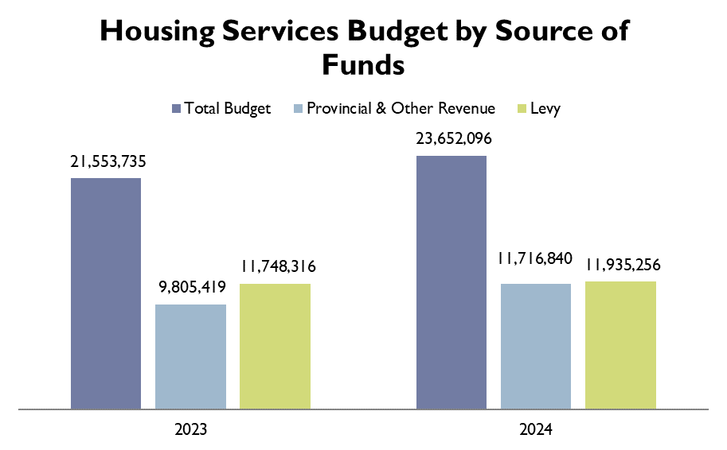



* In 2024, the Housing Services budget has increased year over year by $1,910,585 or 8.86%. This is primarily due to the increase to DNSSAB’s Homelessness Prevention Program (HPP) annual allocation from $2,339,100 to $5,303,700.
* Housing Services is funded by the Ministry of Municipal Affairs and Housing (MMAH), the Federal government, and the municipal levy. There are many different program components that make up the department budget. The below table describes how each are funded (some similar programs are combined for simplicity):

|  |  |
| --- | --- |
| Program | Funding Source |
| Social Housing Subsidies | There is some legacy federal funding that is tied to operating agreements/mortgages; however, the majority of this budget is funded by the municipal levy. The levy contribution is calculated as the difference between the required subsidies and the federal funding. |
| Commercial Rent Supplements | Similar to social housing subsidies, there is some legacy federal funding; however, the majority of this budget is funded by the municipal levy. The levy contribution is calculated as the difference between the required rent supplements and the federal funding. |
| Portable Housing Benefit (Rent Supplement) | 100% funded by the municipal levy |
| Homelessness Prevention Program (HPP) | 100% funded by MMAH |
| Canada-Ontario Community Housing Initiative (COCHI) | 100% funded by MMAH through a provincial and federal bi-lateral agreement |
| Ontario Priorities Housing Initiative (OPHI) | 100% funded by MMAH through a provincial and federal bi-lateral agreement |
| Canada-Ontario Housing Benefit (COHB) | 100% funded by MMAH through a provincial and federal bi-lateral agreement |
| Reaching Home | 100% federally funded through Infrastructure Canada |
| Northern Pines | Combination of provincial funding through HPP and the municipal levy |
| Low Barrier Shelter | Combination of provincial funding through HPP and the municipal levy |
| Program Delivery | Combination of provincial funding through administration allocations for the various provincial/federal funded programs (HPP, COCHI, OPHI, COHB, and Reaching Home) and the municipal levy |

#### 3.4.1 Housing Services Programs

* Funding for social housing programs is generally determined by adjusting previous year expenses by provincially legislated cost indices. There is base federal/provincial funding that is tied to operating agreements and the municipal levy funds the difference between the required subsidies and federal/provincial funding. The provincial/federal funding does not change year over year (except decreasing with the expiration of operating agreements), therefore in a typical year, the proportion of municipal funding required to support social housing providers gradually increases over time. This is not the case in 2024 as several mortgages/operating agreements are expiring, reducing the required subsidies in 2024.
* Subsidy requirements for Nipissing District Housing Corporation’s (NDHC) Phase III have decreased by $22,216, however, there is a $129,444 increase to the municipal levy as legacy federal funding for this program decreased by $151,660 for 2024. The federal funding that helps offset these costs is gradually being reduced each year with 2029 being the last year with federal funding.
* Legislation outlines the DNSSAB’s service level standards (SLS) which details the specific number of Rent Geared-to-Income (RGI) units that are required to be funded. DNSSAB is currently not meeting this obligation and is short approximately 233 RGI housing units as of December 31, 2022. The SLS Action Plan sees the DNSSAB making gradual investments over a 10-year period to address the SLS shortfall. This is the reasoning for the net increase to the Commercial Rent Supplement and Portable Housing Benefit budgets. Both of these programs provide rent subsidies to clients, which count towards the SLS. Increases to rent subsidies are funded through the municipal levy. Significant strides have been made recently that are not reflected in the December 31, 2022 SLS figure above:
  + Northern Pines Phase 2 (20 units) will be subsidized and count towards the SLS.
  + Rent supplements are being phased in at Mackay Homes upon unit turnover. There are 65 units at Mackay Homes and it is estimated to take up to 10 years to turn over all these units.
  + Rent Supplements will be provided to subsidize 24 units at the former J.W. Trusler school in North Bay. These will count towards SLS.
* The HPP, Reaching Home, Community Capacity and Innovation, COCHI, and OPHI programs are fully funded by the provincial and federal governments for homelessness initiatives and to address local housing priorities that include affordability, repair and new construction. Housing staff bring forward regular reports to the Board to approve investment plans detailing how these funding allocations will be expended.
* After the 2023 budget was approved, the Province announced a significant increase to DNSSAB’s HPP annual allocation from $2,339,100 to $5,303,700. This enhanced allocation will eliminate the need to use reserves and will help to mitigate future increases to the municipal levy at the current service levels.
* Northern Pines and the Low Barrier Shelter are both operated by Crisis Centre North Bay. Costs for these programs increase annually due to collective bargaining and inflationary increases. Available HPP funding is used where possible to offset the impact on the municipal levy, however, with HPP funding being fixed, annual increases to these budgets will need to be funded by the municipal levy.

#### 3.4.2 Affordable Housing Reserve

* Given the sharp increase in interest rates that started in 2022, DNSSAB is currently earning excess interest revenue. It is recommended that this excess interest revenue, which is estimated at approximately $1.1 million for 2024, be placed in the Affordable Housing Reserve. The actual excess revenue for 2024 will not be known until the 2024 yearend process is completed in early 2025, so it is recommended that the amount to be transferred be at the discretion of the Manager of Finance.
* Because interest rates will gradually come back down, it is not recommended to use this excess revenue to offset operating costs as this will only put more pressure on the municipal levy in future years. Reserves also need to be grown to take advantage of future funding opportunities for housing development. Most housing development funding is currently application based with scoring grids, and higher scores are awarded for projects that have higher equity contributions. Therefore, to be successful in funding applications, appropriate levels of reserves are needed to support the required equity contributions.

#### 3.4.3 Housing Services Program Delivery

* The Housing Services program delivery budget has increased year over year by $135,015 or 7.82%. This is primarily due to the increased HPP allocation noted above as current provincial funding allocations include a 5% administration allocation. Despite the increase in the budget, the municipal levy contribution is decreasing $14,508 or 1.05%.

## 3.5 Paramedic Services

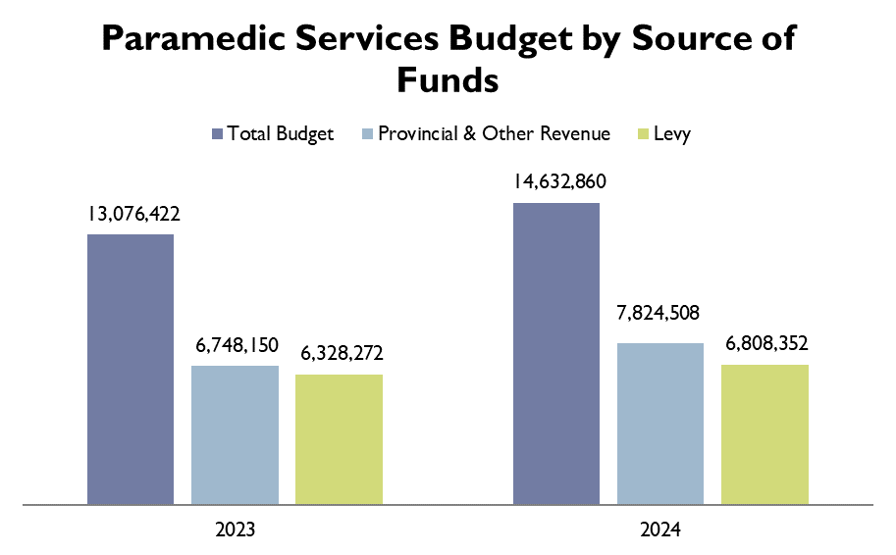

#### 3.5.1 Paramedic Services Provincial Funding Impact

On August 22, 2023, during the AMO conference, the Ontario government announced they were increasing 2023 land ambulance funding to municipalities by an average of six per cent. This has been the process for several years now where current year funding increases are announced in August. Therefore, DNSSAB will likely not receive confirmation of land ambulance funding for 2024 until August of 2024. Given the fact that funding has continued to increase with inflation each year, it is expected that the funding formula will remain the same for 2024.

The method in which the Land Ambulance Service Grant (LASG) is calculated (in a simplified way) is that the DNSSAB receives 50% of its previous year’s approved budget plus a 100% portion to cover territories without municipal organization (TWOMO) and First Nations funding. Therefore, the 2024 50/50 provincial funding will be based on the 2023 budget as opposed to the 2024 budget. The issue with this is that the provincial funding is then a year behind on budget increases from call volume changes, service enhancements and inflationary increases. The Ministry of Health (MOH) had previously addressed this timing difference by including an incremental (inflationary) increase to the previous year budget. In 2018, this incremental increase was 1.7% or $150,658. For 2019 through 2023, this incremental increase was set at 0%.

#### 3.5.2 Paramedic Services Program



* In November 2021, the Board approved a transition to a direct delivery model for paramedic services effective prior to January 1, 2023. The transition was completed in December 2022. Paramedic Services was previously contracted out to North Bay Regional Health Centre (North Bay and area, West Nipissing, and South Algonquin), Mattawa Hospital (Mattawa and area) and the Municipality of Temagami (Temagami).
* Due to increased call volumes, employee recruitment and retention issues, and the need to meet response time standards, the 2024 Paramedic Services budget increases deployment hours in Mattawa from eight (8) hours on-site and sixteen (16) hours on-call to a twenty-four (24) hour on-site service. Deployment hours for Temagami and South Algonquin are also increasing from eight (8) hours on-site and sixteen (16) hours on-call to twelve (12) hours on-site and twelve (12) hours on-call. These changes in deployment are expected to take place part way through the year as recruitment for the additional required positions will take some time. The budget includes the use of $934,000 in reserves to offset the impact on the municipal levy from these deployment changes.
* 2023 was the first year of DNSSAB direct delivery and a very tight budget was prepared in 2023 with only a 1.83% year over year increase from 2022. This was done to minimize the expected large increase to the municipal levy from the operations of Northern Pines, the Low Barrier Shelter, and Emergency Overflow (DNSSAB was not aware of the increased HPP funding at the time of the budget preparation and approval for 2023). Due to high inflation, increased call volume, and other unforeseen costs, Paramedic Services is forecasting for a significant deficit in 2023. Therefore, due to these factors and the changes to the deployment hours noted above, the Paramedic Services budget is increasing by 11.9% in 2024.
* The increase to the Paramedic Services budget is due to collective bargaining increases, inflationary increases, increased call volume and corresponding deployment changes, and required adjustments to the budget based on the first year of experience with direct delivery. Additional details are as follows:
  + High inflation continues to impact all parts of the budget, but inflation tends to impact Paramedic Services more than other departments because a large portion of the Paramedic Services budget is for the purchase of goods and services as opposed to mandated direct client benefits.
  + Two ambulance purchases are planned for 2024, continuing the normal replacement cycle. The cost of ambulances has increased significantly in recent years.
  + The cost of vehicle fuel continues to increase. While short-term fuel prices are difficult to predict due to many global factors that can affect prices, it is expected that prices will continue to increase year over year due to the carbon tax and regular inflation.
  + Various budget lines have been increased significantly such as uniforms, vehicle repairs, medical supplies, and medications based on current year trends.
* General cost drivers:
  + Ontario’s population is aging with the number of people over age 65 projected to double by 2036. Seniors typically make a disproportionate number of 911 calls, so as the population continues to age, increases to both the overall number of calls as well as the severity of calls is expected.[3]
  + The Financial Accountability Office of Ontario forecasted inflation in the health industry to be approximately 4.5% in 2019-20.[4] While this is not specific to Paramedic Services and the data is now outdated, it still demonstrates the impact that the aging population has on health-related costs.

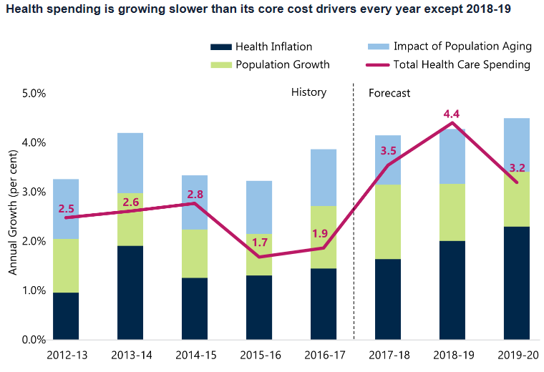

* + Paramedic Services across Ontario have experienced a considerable increase in patient transports. Canadian Journal of Medicine[5] indicates a significant spike in Ontario patient transports of 34% over a ten-year period pre-COVID 19 pandemic. Nipissing District has seen a 22% increase in patient transports over the past five years. Increasing pressures are the urgent (Code 3) and Emergent (Code 4) which are time sensitive and do not permit opportunity to delay or defer. The chart below does not include standby and cancelled calls, only actual patient transports. Standby and cancelled calls account for approximately 10% of calls.

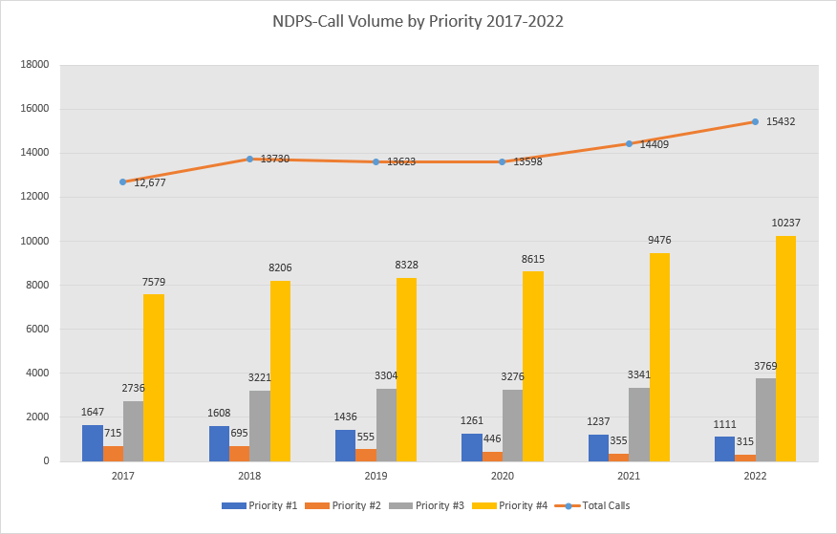

## 3.6 Community Paramedicine



* On March 1, 2021, DNSSAB was approved by the Ministry of Long-Term Care (MLTC) to operate a community paramedicine (CP) program for a three-year period from January 1, 2021 to March 31, 2024. On June 16, 2023, this program was extended for an additional 2-year period, until March 31, 2026. This program (CP LTC) is 100% provincially funded and provides up to $1 million per year. The program is designed to support seniors on the provincial long-term care waitlist, or soon to be eligible for long-term care, with community paramedicine services in the comfort of their own homes.
* Now that the Paramedic Services transition is complete, the DNSSAB has taken over the delivery of two additional CP programs that were previously managed by North Bay Regional Health Centre. These are the CP Base (Base funding) and CP GCOP (Geriatric Community-Paramedicine Outreach Program) programs. These programs are both 100% funded by Ontario Health. The CP GCOP program only has confirmed funding to March 31, 2023, but Ontario Health has expressed the intention to continue this program as ongoing base funding.
* CP ALC (Alternate Level of Care) is a newer program (started in 2023) that is also 100% funded by Ontario Health.
* Total provincial funding for community paramedicine programs is expected to be $1,775,588 in 2024. There is no impact on the municipal levy to operate these programs.

## 3.7 Healthy Communities Fund

The Healthy Communities Fund (HCF) is a non-mandated program administered by the DNSSAB on behalf of the District’s municipalities. Currently, the fund is focused on poverty reduction in Nipissing District. Previously, HCF was allocated to various organizations and their projects/programs through an annual application process. Per briefing note B25-21, that was approved by the Board in November 2021, funding has been annualized to specific organizations based on previous funding allocations and results from a Community Advisory Board survey in April 2021. The table below shows the distribution of funds by organization and their respective programs/services.

The Gateway Hub is being consolidated into the HCF to combine all community funding that does not fall under Ontario Works, Housing Services, Children’s Services or Paramedic Services mandates, into one program. The Gateway Hub is a situation table and was established in the Nipissing district in 2013. A situation table is a strategic alliance of human service providers, guided by common principles and processes, that reviews situations of acutely elevated risk (AER) to determine if an individual or family is at imminent risk of harm and victimization. In cases that are determined to have AER, utilizing a strict four filter process, interventions are coordinated, and lead agencies are identified. Privacy is essential to the success of the Gateway Hub table and only de-identified data for each situation is captured for data analysis and decision-making purposes.

The total annual HCF budget of $320,000 remains unchanged from the previous year.

|  |  |  |
| --- | --- | --- |
| Organization | Program/Service | Annual Funding |
| Crisis Centre North Bay | ID Clinic | $30,000 |
|  | Food Security | $25,000 |
| The Gathering Place | Souper Suppers | $20,000 |
|  | Food Outreach | $30,000 |
| Nipissing First Nation | True Self Debwewendizwin Rural Outreach | $55,000 |
| Salvation Army | Household Setup | $10,000 |
| Low Income People Involvement | Emergency Dental Assistance | $30,000 |
|  | Essential Health | $30,000 |
|  | Denture Assistance | $30,000 |
|  | Community Volunteer Tax Program | $10,000 |
|  | Community Recreation and Engagement | $30,000 |
| North Bay Parry Sound District Health Unit | Gateway Hub | $20,000 |
| Total |  | $320,000 |

## 3.8 Corporate Services

The Corporate Services Division supports the organization through the CAO, Finance, Human Resources, Project Management & Information Services, Purchasing, Planning & Analytics, Risk Management and Administration. The 2024 budgeted expenses for Corporate Services total $3,975,152, an increase of $473,118 (13.51%) over the 2023 approved budgeted expenses of $3,502,034. The primary reason for the increase is technology-related costs. This includes, but is not limited to, City of North Bay information technology services, Microsoft 365 subscriptions, computer hardware replacements, and accounting system upgrades.

The Corporate Services budget includes various corporate-wide costs, for example, staffing for the above departments, rent for office space, utilities, telephone, insurance premiums, audit & legal fees, computer software and more. These costs are allocated across the portfolio of programs. The general mix of expenses has not changed significantly year over year with the exception of technology-related costs as noted above.

The 2024 Corporate Services budget represents 4.19% of the total DNSSAB recommended budget compared to 3.88% in 2023. Per the chart below, DNSSAB continues to have one of the lowest corporate services costs relative to the total budget amongst all the DSSABs.[6]

Staff continue to search for cost savings throughout the organization. Explanations for the significant variances year over year are as follows:

* Increased information technology related costs.
* Inflationary increases.
* Increase in salaries and benefits due to the annual cost of living increase.

## 3.9 Board



In 2024, the Board budget has increased year over year by $7,752 or 4.77% with no significant changes. Honorariums are adjusted to reflect actual attendance levels and annual rate increases. Annual honoraria rate increases continue to be tied to the consumer price index for a fair and transparent process. Honorariums are also based on attendance to reflect the respective contributions of Board members.

## 3.10 Summary

The 2024 budget presents a municipal levy increase of $674,772 (2.99%) with an overall increase in the budget from $90,232,483 in 2023 to $94,775,183 in 2024.



The budget maintains services at the 2023 level while including any service changes that the Board approved in 2023.

As described previously in the Budget, the primary reason for the increase in the municipal levy is the significant increase to the Paramedic Services budget due to inflation, collective bargaining, and increased call volumes and the corresponding increases to deployment hours at the Mattawa, Temagami, and South Algonquin bases.

The budget includes the use of $934,000 in reserves to offset the impact on the municipal levy from the Paramedic Services deployment changes.

# 2025 Outlook

## 4.1 Ontario Works Program Delivery and Employment Assistance Funding

MCCSS is moving forward with modernization changes to OW, including employment services transformation. In September of 2019, MCCSS communicated to OW offices that they should expect reductions to their 2021 funding allocations as a result of modernization changes. This reduction was rumored to be 22%, but this has not been confirmed. Modernization initiatives have been slowed due to the pandemic, delaying the expected funding reduction until at least 2025. It is too early to provide an estimate on this impact as there will be programming changes attached to this funding reduction.

## 4.2 Children’s Services

Allowable administrative funding that CMSMs/DSSABs can spend on childcare has been reduced from 10% to 5% resulting in an estimated decrease of 33% in administrative funding for Children’s Services. This decrease comes at a time when the EDU is also demanding additional reporting and sector oversight with the implementation of CWELCC. Such a significant reduction in administrative funding will limit DNSSAB’s ability to meet these requirements. Advocacy efforts will be made to communicate this issue to the Province.

As noted above in the Children’s Services section of the budget, the optional municipal contribution of $423,431 was removed from the budget in 2023 due to temporary reduced childcare capacity in the District. This municipal levy contribution may need to come back on to the budget in future years to address the childcare waitlist.

## 4.3 Housing Services

As mentioned previously in the Budget, inflation will continue to result in annual budget increases for Northern Pines and The Low Barrier Shelter and additional rent supplements will need to be provided to meet the DNSSAB’s legislated service level standards. These increases will need to be funded by the municipal levy.

Housing Services will see reductions in funding associated with social housing legacy programs in 2025. Provincial and federal funding for social housing will see a year over year reduction of $816,681 or 42.5%. This is a direct result of ten social housing projects reaching the end of their operating agreements throughout 2024 and 2025. Some of these reductions in funding will be offset by reduced subsidy requirements because of expired mortgages.

## 4.4 Paramedic Services

The MOH continues to announce growth rates to funding on a one-year basis. At this time, it is unknown what to expect for Paramedic Services funding in 2025.

The increased deployment hours at the Mattawa, Temagami, and South Algonquin bases will lead to additional pressure on the 2025 budget, as only seven (7) months of the increased costs are included in the 2024 budget. The 2025 budget will include the full annual costs.

1. Bank of Canada Monetary Policy Report October 2023

   https://www.bankofcanada.ca/2023/10/mpr-2023-10-25/
2. These estimates are based on data available as of October 31, 2023 and are subject to change based on various factors such as legislation, emerging trends, labour market changes, etc.
3. OAPC Recommendations from the Provincial Municipal Land Ambulance Dispatch Working Group: Submission to the Minister of Health and Long-Term Care, May 28, 2015, p. 9,

   https://www.oapc.ca/wp-content/uploads/2016/11/Land-Ambulance-Working-Group.pdf
4. Ontario Health Sector - An Updated Assessment of Ontario Health Spending, FAO, p. 2,

   https://www.fao-on.org/en/Blog/Publications/health-sector-march-18
5. Canadian Journal of Emergency Medicine (2022) 24:742–750

   https://doi.org/10.1007/s43678-022-00363-4
6. Chart is organized by DNSSAB’s closest comparators, left to right, based on size of organization, geography, and services provided. Seven other DSSABs had their budgets available on their website. DSSAB 4 in the chart above, only had their 2022 budget available on their website.